
School of Computing and Data Science (SCDS)
Reference No. : XMUM.SCDS (V6)
Effective Date : 7th October 2025

Undergraduate FYP Proposal Form
Section I: Student’s Information:
Full Name | Erawan Gregorius Felix Caton
Student ID | SWE2309430 | Mobile | +62 895365413731
Email ID | SWE2309430@xmu.edu.my | Programme | Software Engineering

Section II : Industry Information: (Complete this section if your project is going to be conducted in partnership with any company)
Company Name
Contact Person
Designation |  | Phone
Email ID

Section III : Declaration by the Student
By signing this form, I confirm that I have read and will adhere to the Final Year Project Proposal Guidelines of Xiamen University Malaysia as applicable to this application.


Signature of Student: ___________________ Date: _3 June 2026_

Section VI : Supervisor Approval
Name of Supervisor | Subashini Raghavan
Office Location | A1#409
Email Address | subashini.raghavan@xmu.edu.my
Office Extension
Signature |  | Date

SECTION V : Proposal Information
Proposed Title (Capitalise each word) (Not more than 20 words)

Design, Development, And Evaluation Of A Web-Based Campus Companion With Navigation, Venue Recommendation, And Canteen Directory For Xiamen University Malaysia

Introduction
(Introduce the context & research gaps/problem) (300-400 words)

Aims and Objectives
(What & how) (100-150 words)

Literature Review
(Related works) (1000-1300 words)

Research Methodology
(Data collection / system design, tools & technologies / datasets, & Evaluation methods (Ex. testing, user study, simulation) (300-500 words)

Scope & Limitations (100-150 words)

Potential Project Significance (100-200 words)

Expected Outcomes & Concluding Remarks
(Deliverables, expected results & conclusions) (200-300 words)

Key References
(Recent references APA 7th Edition) (10-20 references APA style)
Antony, C. (2022). Canteen Food Ordering and Managing System. International Journal of Current Science Research and Review, 05(06). https://doi.org/10.47191/ijcsrr/V5-i6-51
Choudhari, P. Y. D. (2024). Campus Compass Android App. International Journal for Research in Applied Science and Engineering Technology, 12(9), 1274–1279. https://doi.org/10.22214/ijraset.2024.64353
Elalami, M. E., Elshafei, I. A., & Abdelkader, H. E. (2022). LOCATION-BASED SERVICES USING WEB-GIS BY AN ANDROID PLATFORM TO IMPROVE STUDENTS’ NAVIGATION DURING COVID-19. Journal of Theoretical and Applied Information Technology, 100(10). www.jatit.org
Gryzun, L. E., Shcherbakov, O. v., & Bida, B. O. (2023). Development of the information system for navigation in modern university campus. CEUR Workshop Proceedings, 3364, 108–126. https://doi.org/10.55056/cte.566
Jalaludin, A., Azizan, A., & Khairudin, N. (2023). ONLINE FOOD ORDERING SYSTEM FEATURING CHATBOT FOR CAFETERIA IN UITM TAPAH. Malaysian Journal of Computing, 8(2), 1534–1547. https://doi.org/10.24191/mjoc.v8i2.23927
Kunhoth, J., Karkar, A. G., Al-Maadeed, S., & Al-Ali, A. (2020). Indoor positioning and wayfinding systems: a survey. In Human-centric Computing and Information Sciences (Vol. 10, Issue 1). Springer. https://doi.org/10.1186/s13673-020-00222-0
Nayakwadi, V. (2025). Smart Campus Navigation System: Enhancing Wayfinding Using AI and IoT Integration. International Journal for Research in Applied Science and Engineering Technology, 13(12), 884–888. https://doi.org/10.22214/ijraset.2025.75716
Neelakantappa B B, M., Madhura S, Meghana, & Mandara. (2025). Smart Campus Navigation System. IJFMR250134970, 7(1).
Prandi, C., Delnevo, G., Salomoni, P., & Mirri, S. (2021). On supporting university communities in indoor wayfinding: An inclusive design approach. Sensors, 21(9). https://doi.org/10.3390/s21093134
S, A. R., Yaragatti, A. G., Mathapati, G., Kulkarni, D., & Jarali, V. (2025). International Journal of Research Publication and Reviews SMART CAMPUS NAVIGATION APP. In International Journal of Research Publication and Reviews (Issue 6). www.ijrpr.com
Tahir, R., & Krogstie, J. (2023). Impact of Navigation Aid and Spatial Ability Skills on Wayfinding Performance and Workload in Indoor-Outdoor Campus Navigation: Challenges and Design. Applied Sciences (Switzerland), 13(17). https://doi.org/10.3390/app13179508

Gantt Chart

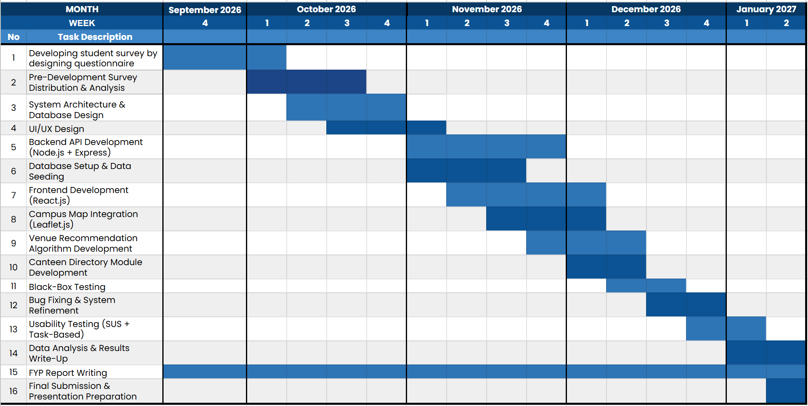

_________________________________
2 Please follow APA style of referencing.

The length of the proposal should be between 2000-3000 (Excluding proposed title & references)

